Chapter X

Focus on OOP, Class Interaction

Chapter X Topics
10.1 Introduction
10.2 Composition with the Point Class
10.3 The Trunk Class
10.4 The Leaves Class
10.5 Class Interaction with Composition
10.6 Class Interaction with Inheritance
10.7 Inheritance Constructor issues
10.8 Calling a Superclass Method
10.9 The Object Class
10.10 Re-defining the toString Method
10.11 Re-defining the equals Method
10.12 Summary

10.1 Introduction

Chapter IV introduced Object Oriented Programming. We took small steps and started by explaining how to use class methods and object methods. In some later chapters you learned how to declare your own classes and how to create your own class methods and object methods. These early chapters set the stage so that you would be ready to understand Object Oriented Programming more formally. Encapsulation was explained in the last chapter and started the first OOP Focus. Encapsulation is the OOP feature whereby the data of an object and all the methods, which access the data, are placed in the same container. Understanding encapsulation is very important in learning OOP, but it is only the first step.

The previous chapter taught you how to create a class and how to create the attributes and methods that are members of the class. You also observed that a second testing class was used to see if your new class works properly. Besides learning how to test a class, nothing was shown about how multiple classes are used together. How do they connect? How do they interact? This is the second OOP focus that will be discussed in this chapter. Class interaction is further divided into inheritance and composition.

Object Oriented Programming is very popular for a good reason. There are so many features that make a program better designed, more reliable, easier to test and simpler to update than previous, non-OOP programs used to be. You have already seen a fair amount of encapsulation and learned the benefits of placing methods and data in the same module, along with constructors. Now let us see what class interaction with inheritance and composition can do for the programmer. Do not be alarmed if you do not instantly see the great benefits of all this OOP stuff. OOP is very powerful, but it takes time to reach a comfort level with this programming approach.

Imagine that you are very creative in designing custom vans. You know just how to replace regular seats with comfortable “captain” seats, add attractive paneling, provide lots of lights, install an entertainment system, add a small shower, add a small kitchen and include many other goodies to make a simple van become a terrific vehicle for long road trips.

Now are you interested in putting together the basic chassis, the frame, the doors, the engine, the transmission, the drive shaft, the air-conditioning and all the other details that a van requires? No, you do not care. Engines, transmissions and air-conditioning are simply not your concern. Your only concern is designing a comfortable, custom van. The solution is to go out and get a fully functional basic van. Now with that van you can get to work. This means that any one of your custom vans first and foremost is-a-van. This is a very important concept and it is called the is-a relationship.

Geometry does a nice job explaining this concept. Geometry starts with very elementary concepts like points and lines. Then theorems and definitions are created that continually build upon previous knowledge. Everywhere the assumption is that previous definitions may be used. For example, the definition of a rectangle does not need to start from scratch. You can state that a rectangle is a parallelogram with four right angles. The assumption is that the definition of a parallelogram is known. This process can continue by stating that a square is a rectangle with four equal sides. All through Geometry you will see the is-a statements used. This style of definition is very efficient. You establish a logical sequence of information and provide definitions that are based on a clear understanding of previous elements in the sequence. Basically, you stop reinventing the wheel on a regular basis.

Let us switch to computer science and see how this inheritance business might apply. You are a number-one-awesome programmer and you have just finished creating a Window class. Now this Window class is a beauty, because you can now display a window anywhere on the monitor. The window can minimize, maximize and you can drag the window to any location. You are rightfully very proud of your new Window class.

Now you want to expand the capability of your Window class and use it to enter text. This adds a whole new dimension of capabilities to your humble Window class. Now, your new class - let us call it TextWindow - needs to still do everything that the plain old vanilla Window class did and more. It is possible to start from scratch, but that would be as efficient as our van converter person who first builds his own vans from scratch before customizing them for special needs. The secret is to start with the Window class and use all its capabilities for a new class called TextWindow. In computer science we say that TextWindow inherits from Window. Such an approach saves time and it adds tons of reliability. Just imagine that you are using an existing class that withstood the test of time. The class has been used over and over again, and all the bugs are corrected. Everybody is happy with your nifty Window class. Now do not touch or alter Window. Start a new class, but do it in such a way that it is capable of using all the nicely tested features that are available with the existing Window class. In a nutshell that is inheritance.

Inheritance Definition
Inheritance is the process of using features (both attributes and methods) from an existing class. The existing class is called the superclass and the new class, which inherits the superclass features, is called the subclass.

Students frequently make a common mistake with inheritance. They confuse the "is-a" relationship with the "has-a" relationship. Both relationships involve class interaction and both are very useful in computer science, but they are very different. Go back to the van example. Our van custom converter started with a fully functional van and customized it. The finished product “is-a” van.

Now when the van was first assembled it was a different story. Many different assembly lines converged to create the van. The van “has-an” engine, and it “has-a” transmission, and it “has” doors. The van is composed of many parts, but it is incorrect to state a van “is-a” door.

The confusion starts because in both cases something new is created with existing components. However there is a big difference between the two creations. With composition a new item is created that is composed of many existing parts. This is the case of assembling a van with a frame, wheels, doors, seats, engine, and all the other van parts.

Now inheritance also uses something that already exists, but the whole item is used and then enhanced. A square is a special type of rectangle. A tiger is one particular type of cat. An off-road truck is first a truck. Take the example of the off-road truck. You can buy a regular truck. Now you put in special shocks that provide greater clearance. You also add four-wheel drive and a locking differential feature. You add special tires that will do well in mud and snow and your original truck is now an off-road truck. However, it is still a truck.

“Is-A” and “Has-A”
The creation of new classes with the help of existing classes makes an important distinction between two approaches.

An is-a relationship declares a new class as a special
“new-and-improved” case of an existing class. In Geometry, a parallelogram is-a quadrilateral with special properties.

A has-a relationship declares a new class composed of an existing class or classes. A line has points, a square has lines, and a cube has squares.

A truck is-a vehicle, but it has-an engine.

In computer science an is-a relationship involves class interaction that is called inheritance and a has-a relationship involves class interaction that is called composition.

10.2 Composition with The Point Class

Imagine that you are building a car like Henry Ford, who invented the assembly line of car building. Henry Ford’s car were not assembled on a single line. There were smaller assembly lines. Each one of these smaller assembly lines created a chassis, doors, engines, transmissions, etc. At the conclusion of the engine assembly line, the completed engine meets up with the main car assembly, precisely at the point when the car is ready to get its engine. A car has-an engine is a good example of composition. In this chapter a group of programs will show the development of different classes. When these classes are finished, all of the classes will then become part of a larger class. Program Java1001.java, in figure 10.1, shows the beginning of the Point class.

Figure 10.1
// Java1001.java
// This program introduces the first stage of <Point> class, which
// stores the (X,Y) values of one coordinate graphics location.
public class Java1001
{
public static void main(String[ ] args)
{
Point point = new Point();
System.out.println("Point at (" + point.getX() + "," + point.getY() + ")");
}
}
class Point
{
private int x;
private int y;
public Point()
{
x = 0;
y = 0;
}
public int getX()
{
return x;
}
public int getY()
{
return y;
}
}
Figure 10.1 Continued
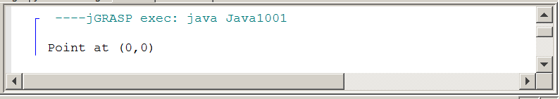

This Point class stores and displays the coordinate information for a single point. The class has a default constructor, which stores a point at coordinate (0,0).

Program Java1002.java, in figure 2, adds an overloaded constructor. It is now possible to create a Point object with specified values during object construction. In the second stage the this reference is intentionally used to help remind you that there are potential issues with passing information to object attributes.

Figure 10.2
// Java1002.java
// The <Point> class is improved with a second "overloaded" constructor.
public class Java1002
{
public static void main(String[ ] args)
{
Point point1 = new Point();
System.out.println("Point1 at (" + point1.getX() + "," + point1.getY() + ")");
Point point2 = new Point(500,300);
System.out.println("Point2 at (" + point2.getX() + "," + point2.getY() + ")");
}
}
class Point
{
private x, y;
public Point()
{
x = 0;
y = 0;
}
public Point(int x, int y)
{
this.x = x;
this.y = y;
}
public int getX() { return x; }
public int getY() { return y; }
}
Figure 10.2 Continued
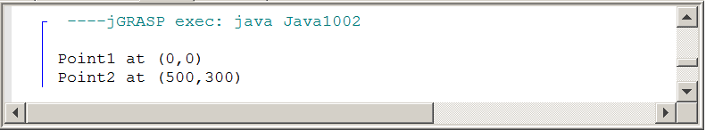

Is there any practical value in a Point class? By itself no, but program Java1003.java, in figure 10.3, shows how a Point object can be used in a graphics program. The object stores the top-left coordinate of a rectangle.

Figure 10.3
// Java1003.java
// The <Point> class is now used in a graphics program.
import java.awt.*;
import java.applet.*;
public class Java1003 extends Applet
{
public void paint(Graphics g)
{
Point point1 = new Point();
g.setColor(Color.red);
g.fillRect(point1.getX(),point1.getY(),400,300);
Point point2 = new Point(300,200);
g.setColor(Color.blue);
g.fillRect(point2.getX(),point2.getY(),450,200);
}
}
class Point
{
private int x, y;
public Point()
{
x = 0; y = 0;
}
public Point(int x, int y)
{
this.x = x; this.y = y;
}
public int getX() { return x; }
public int getY() { return y; }
}

Figure 10.3 Continued
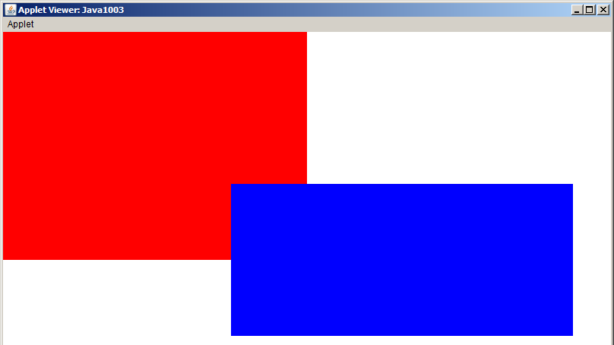

The Point class has the ability to story any coordinate values, but once the initial object is constructed those coordinates values are fixed. Program Java1004.java, in figure 10.4, solves that problem by adding two set methods to alter the initial coordinate x-value and y-value during program execution.

Figure 10.4
// Java1004.java
// This program adds two set methods to the <Point> class.
// Note how "one-statement" methods are written on one line.
import java.awt.*;
import java.applet.*;
public class Java1004 extends Applet
{
public void paint(Graphics g)
{
Point point1 = new Point();
g.setColor(Color.red);
g.fillRect(point1.getX(),point1.getY(),400,300);
Point point2 = new Point(300,200);
g.setColor(Color.blue);
g.fillRect(point2.getX(),point2.getY(),450,200);
point2.setX(100);
point2.setY(100);
g.setColor(Color.green);
g.fillRect(point2.getX(),point2.getY(),500,500);
}
}
class Point
{
private int x, y;
public Point()
{
x = 0;
y = 0;
}
public Point(int x, int y)
{
this.x = x;
this.y = y;
}
public int getX() { return x; }
public int getY() { return y; }
public void setX(int x) { this.x = x; }
public void setY(int y) { this.y = y; }
}

Figure 10.4 Continued
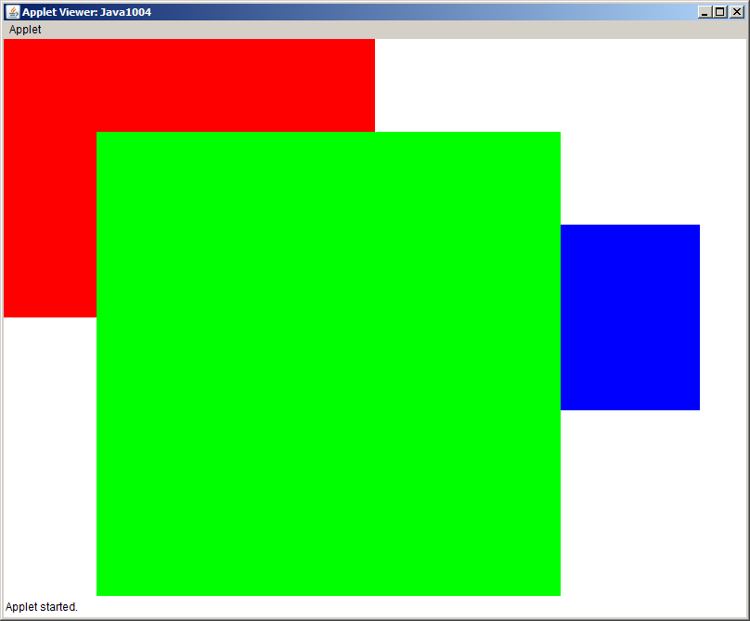
For our teaching purposes the Point class is now ready to be used by another program. The class does not need to be altered, but it needs to be placed in a separate file. Program Java1005.java, in figure 10.5 tests the Point class and Point.java, in figure 10.6, is now a separate file.

Figure 10.5
// Java1005.java
// The <Point> class is placed in an external "stand-alone" file.
// This follows the general rule of "one class, one file."
import java.awt.*;
import java.applet.*;
public class Java1005 extends Applet
{
public void paint(Graphics g)
{
Point point1 = new Point();
g.setColor(Color.red);
g.fillRect(point1.getX(),point1.getY(),400,300);
Point point2 = new Point(300,200);
g.setColor(Color.blue);
g.fillRect(point2.getX(),point2.getY(),450,200);
point2.setX(100);
point2.setY(100);
g.setColor(Color.green);
g.fillRect(point2.getX(),point2.getY(),500,500);
}
}
// Point.java
// This is the completed <Point> class kept in its own file.
// This class is now ready to be used by classes external to this file.
public class Point
{
private int x, y;
public Point()
{
x = 0; y = 0;
}
public Point(int x, int y)
{
this.x = x; this.y = y;
}
public int getX() { return x; }
public int getY() { return y; }
public void setX(int x) { this.x = x; }
public void setY(int y) { this.y = y; }
}
Figure 10.5 Continued
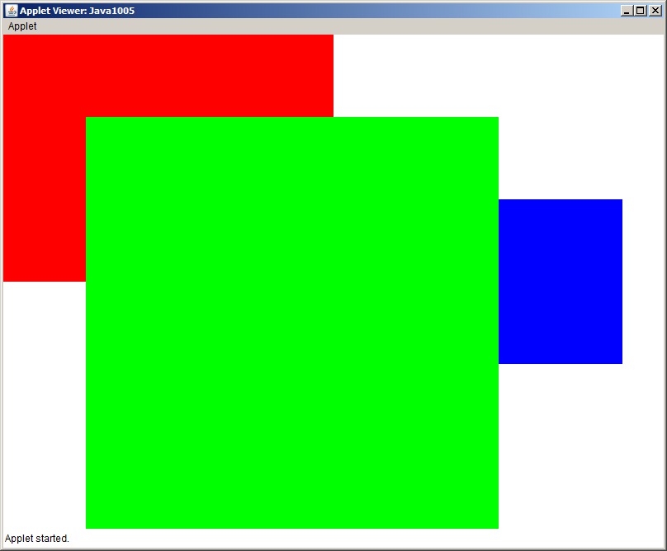

10.3 The Trunk Class

Yes, this is a chapter about class interaction with composition and inheritance. And yes, there has not been any examples of class interaction. The primary intention of class interaction is that existing classes – who have already been thoroughly tested – are used in the creation of other classes. In other words the whole composition and inheritance business does not function unless there first are classes available that can be used for class interaction. For a number of program examples you will observe various stages that develop a class. Once these initial classes are presented, class interaction can get started.

The second class that will be shown in stages is the Trunk class. This is neither the trunk of an elephant nor a trunk to store clothes. It is the trunk of a tree. Program Java1006.java, in figure 10.6, shows the initial stage. Data attributes are used for the top-left corner of the trunk coordinate location. There are also attributes for the height, width and color of the trunk. This first Trunk class only has a default constructor and method drawTrunk to display a Trunk object.

Figure 10.6
// Java1006.java
// This program introduces the <Trunk> class.
// The program displays a tree trunk using only a default constructor.
import java.awt.*;
import java.applet.*;
public class Java1006 extends Applet
{
public void paint(Graphics g)
{
Trunk trunk = new Trunk();
trunk.drawTrunk(g);
}
}
class Trunk
{
private int trunkStartX;
private int trunkStartY;
private int trunkHeight;
private int trunkWidth;
private Color trunkColor;
public Trunk()
{
trunkStartX = 0;
trunkStartY = 0;
trunkHeight = 320;
trunkWidth = 80;
trunkColor = Color.black;
}
public void drawTrunk(Graphics g)
{
g.setColor(trunkColor);
g.fillRect(trunkStartX,trunkStartY,trunkWidth,trunkHeight);
}
}

Figure 10.6 Continued
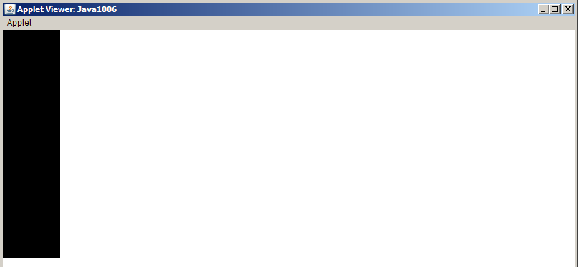

Program Java1007.java, in figure 10.7, adds an overloaded constructor to add some variety to a dull, black trunk at the top-left corner of the graphics window.

Figure 10.7
// Java1007.java
// The <Trunk> class now uses a overloaded constructor that
// allows construction with the trunk's location, height and color.
import java.awt.*;
import java.applet.*;
public class Java1007 extends Applet
{
public void paint(Graphics g)
{
Trunk trunk1 = new Trunk();
Trunk trunk2 = new Trunk(350,400,75,300,Color.orange);
trunk1.drawTrunk(g);
trunk2.drawTrunk(g);
}
}
class Trunk
{
private int trunkStartX, trunkStartY;
private int trunkHeight, trunkWidth;
private Color trunkColor;
public Trunk()
{
trunkStartX = 0;
trunkStartY = 0;
trunkHeight = 320;
trunkWidth = 80;
trunkColor = Color.black;
}
public Trunk(int tX, int tY, int tW, int tH, Color tC)
{
trunkStartX = tX;
trunkStartY = tY;
trunkHeight = tH;
trunkWidth = tW;
trunkColor = tC;
}
public void drawTrunk(Graphics g)
{
g.setColor(trunkColor);
g.fillRect(trunkStartX,trunkStartY,trunkWidth,trunkHeight);
}
}

Figure 10.7 Continued
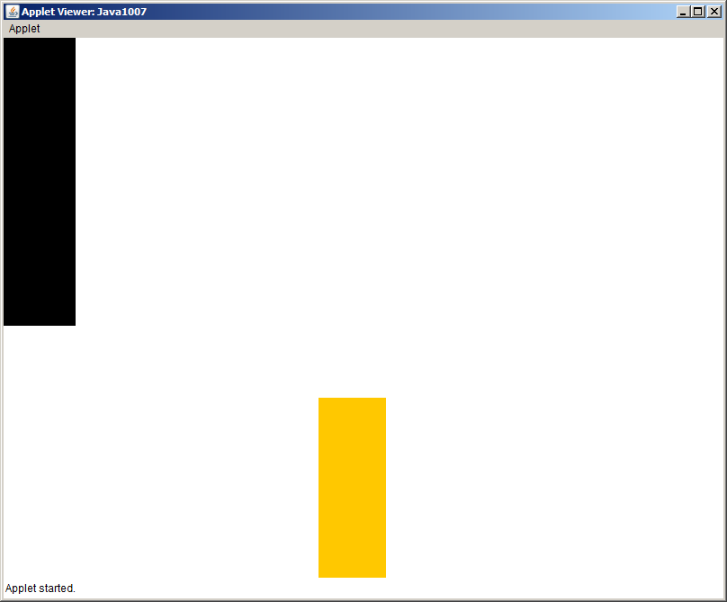

You should have noticed that the overloaded constructor of the Trunk class passed information about the top-left coordinate values of the trunk location. Well we have a perfectly good Point class, which specializes in handling coordinate values. Program Java1007.java, in figure 10.7, uses an object of the Point class to indicate the starting location of the Trunk object.

Figure 10.8
// Java1008.java
// This <Trunk> class uses "has-a" composition. In this example, a <Point> object is
// constructed outside the <Trunk> class and passed as parameter.
import java.awt.*;
import java.applet.*;
public class Java1008 extends Applet
{
public void paint(Graphics g)
{
Trunk trunk1 = new Trunk();
trunk1.drawTrunk(g);
Point point2 = new Point(350,400);
Trunk trunk2 = new Trunk(point2,75,300,Color.orange);
trunk2.drawTrunk(g);
}
}
class Trunk
{
private Point trunkStart;
private int trunkHeight, trunkWidth;
private Color trunkColor;
public Trunk()
{
trunkStart = new Point(0,0);
trunkHeight = 320;
trunkWidth = trunkHeight/4;
trunkColor = Color.black;
}
public Trunk(Point tS,int tW, int tH, Color tC)
{
trunkStart = tS; trunkHeight = tH;
trunkWidth = tW; trunkColor = tC;
}
public void drawTrunk(Graphics g)
{
g.setColor(trunkColor);
g.fillRect(trunkStart.getX(),trunkStart.getY(),trunkWidth,trunkHeight);
}
}
The output display is identical to the previous program. Now let us examine the class interaction with composition. In this case we see that a Trunk object is constructed with a Point object. A trunk has-a point. You will see two highlighted statements in figure 10.8. The first one shows a rather normal declaration of a class attribute, also called an instance variable. The difference is that it is an object and not a simple data type. The second highlight, inside the constructor, instantiates a new Point object. Like the Point class, the Trunk class get a variety of set methods and is now almost fully functional. You may not be very impressed by this trunk, in figure 10.9, which looks suspiciously like a plain rectangle. Students with artistic skills can add realistic bark and other features.

Figure 10.9
// Java1009.java
// The <Trunk> class is now complete with four get" methods and four "set" methods.
import java.awt.*;
import java.applet.*;
public class Java1009 extends Applet
{
public void paint(Graphics g)
{
Trunk trunk1 = new Trunk();
trunk1.drawTrunk(g);
Point point2 = new Point(350,400);
Trunk trunk2 = new Trunk(point2,75,300,Color.red);
trunk2.drawTrunk(g);
}
}
class Trunk
{
private Point trunkStart;
private int trunkHeight, trunkWidth;
private Color trunkColor;
public Trunk()
{
trunkStart = new Point(0,0);
trunkHeight = 320;
trunkWidth = trunkHeight/4;
trunkColor = Color.black;
}
public Trunk(Point tS,int tW, int tH, Color tC)
{
trunkStart = tS;
trunkHeight = tH;
trunkWidth = tW;
trunkColor = tC;
}
public Point getTrunkStart() { return trunkStart; }
public int getTrunkHeight() { return trunkHeight; }
public int getTrunkWidth() { return trunkWidth; }
public Color getTrunkColor() { return trunkColor; }
public void setTrunkStart(Point tP) { trunkStart = tP; }
public void setTrunkHeight(int tH) { trunkHeight = tH; }
public void setTrunkWidth(int tW) { trunkWidth = tW; }
public void setTrunkColor(Color tC) { trunkColor = tC; }
public void drawTrunk(Graphics g)
{
g.setColor(trunkColor);
g.fillRect(trunkStart.getX(),trunkStart.getY(),trunkWidth,trunkHeight);
}
}

Figure 10.9 Continued
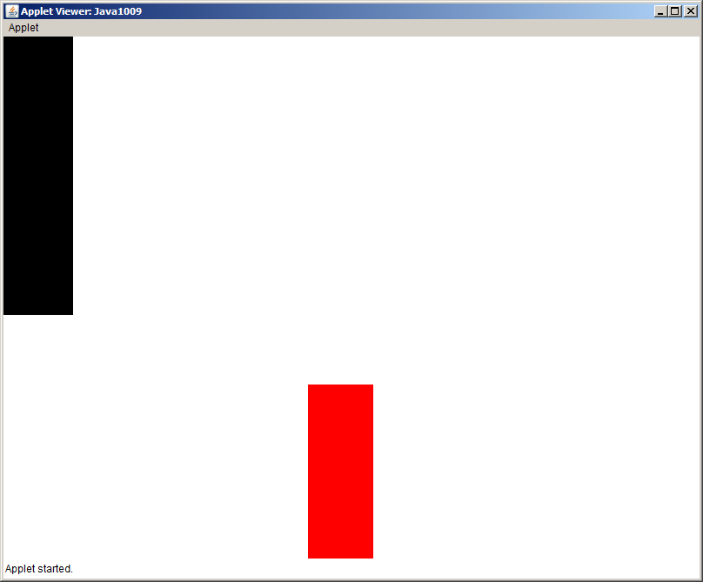

Program Java1010.java, in figure 10.10, tests the completed Trunk class, which is now placed in its own file. At this stage there are two complete classes, the Point class and the Trunk class. The Trunk class uses the existing Point class to declare one of its attributes. This means that the class interaction between the two classes is composition.

Figure 10.10
// Java1010.java
// The <Trunk> class can now join the <Point> class
// as a stand-alone class ready to be used by other classes.
import java.awt.*;
import java.applet.*;
public class Java1010 extends Applet
{
public void paint(Graphics g)
{
Trunk trunk1 = new Trunk();
trunk1.drawTrunk(g);
Point point2 = new Point(350,400);
Trunk trunk2 = new Trunk(point2,75,300,Color.red);
trunk2.drawTrunk(g);
}
}

10.4 The Leaves Class

The Point class and the Trunk class may not seem all that practical. Please have patience. One more class will be introduced and then the class interaction will start to take shape in a more realistic manner. Keep in mind that using existing classes does mean that some classes have to be created first. The third class that you need to examine is the Leaves class.

Program Java1011.java, in figure 10.11, shows that the Leaves class has a starting point, just like the Trunk class. An object of the Point class will store the coordinate values. Right now objects of the Leaves class are strictly circular shapes.

Figure 10.11
// Java1011.java
// The <Leaves> class simulates tree leaves. At this stage the leaves are only round.
import java.awt.*;
import java.applet.*;
public class Java1011 extends Applet
{
public void paint(Graphics g)
{
Leaves leaves1 = new Leaves();
leaves1.drawLeaves(g);
Point start = new Point(400,100);
Leaves leaves2 = new Leaves(start,300,300,Color.green);
leaves2.drawLeaves(g);
}
}
class Leaves
{
private Point leavesStart;
private int leavesWidth;
private int leavesHeight;
private Color leavesColor;
public Leaves()
{
leavesStart = new Point(0,0);
leavesWidth = 200;
leavesHeight = 200;
leavesColor = Color.black;
}
public Leaves(Point lS, int lW, int lH, Color lC)
{
leavesStart = lS;
leavesWidth = lW;
leavesHeight = lH;
leavesColor = lC;
}
public void drawLeaves(Graphics g)
{
g.setColor(leavesColor);
g.fillOval(leavesStart.getX(),leavesStart.getY(),leavesWidth,leavesHeight);
}
}

Figure 10.11 Continued
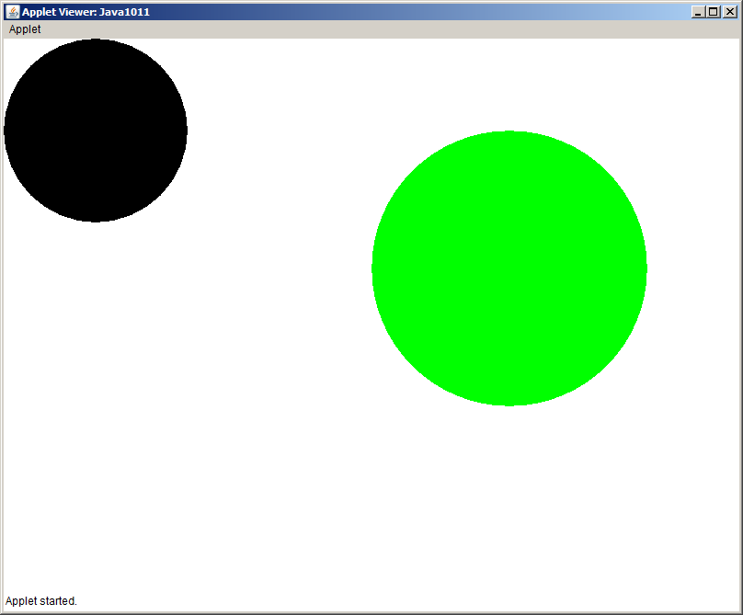

It takes the Leaves class fewer stages to reach the complete stage than the previous classes. You will notice a pattern and the Trunk and Leaves classes are very similar in their organization. It is not necessary to show as many stages as were used for the first two classes. Program Java1012.java, in figure 10.12, adds get methods and set methods for proper access to the data attributes.

The pattern then continues as the completed Leaves class now is ready to operate inside its own file. Java1013.java, in figure 10.13, also becomes a separate testing class, which checks the Leaves class, which joins the Point class and Trunk class to be ready for class interaction.

Figure 10.12
// Java1012.java
// The <Leaves> class is now complete with four "get" methods and four "set" methods.
import java.awt.*;
import java.applet.*;
public class Java1012 extends Applet
{
public void paint(Graphics g)
{
Leaves leaves1 = new Leaves();
leaves1.drawLeaves(g);
Point start = new Point(400,100);
Leaves leaves2 = new Leaves(start,300,300,Color.green);
leaves2.drawLeaves(g);
}
}
class Leaves
{
private Point leavesStart;
private int leavesWidth;
private int leavesHeight;
private Color leavesColor;
public Leaves()
{
leavesStart = new Point(0,0);
leavesWidth = 200;
leavesHeight = 200;
leavesColor = Color.black;
}
public Leaves(Point lS, int lW, int lH, Color lC)
{
leavesStart = lS;
leavesWidth = lW;
leavesHeight = lH;
leavesColor = lC;
}
public Point getLeavesStart() { return leavesStart; }
public int getLeavesHeight() { return leavesHeight; }
public int getLeavesWidth() { return leavesWidth; }
public Color getLeavesColor() { return leavesColor; }
public void setLeavesStart(Point lP) { leavesStart = lP; }
public void setLeavesHeight(int lH) { leavesHeight = lH; }
public void setLeavesWidth(int lW) { leavesWidth = lW; }
public void setLeavesColor(Color lC) { leavesColor = lC; }

public void drawLeaves(Graphics g)
{
g.setColor(leavesColor);
g.fillOval(leavesStart.getX(),leavesStart.getY(),leavesWidth,leavesHeight);
}
}

Figure 10.12 Continued
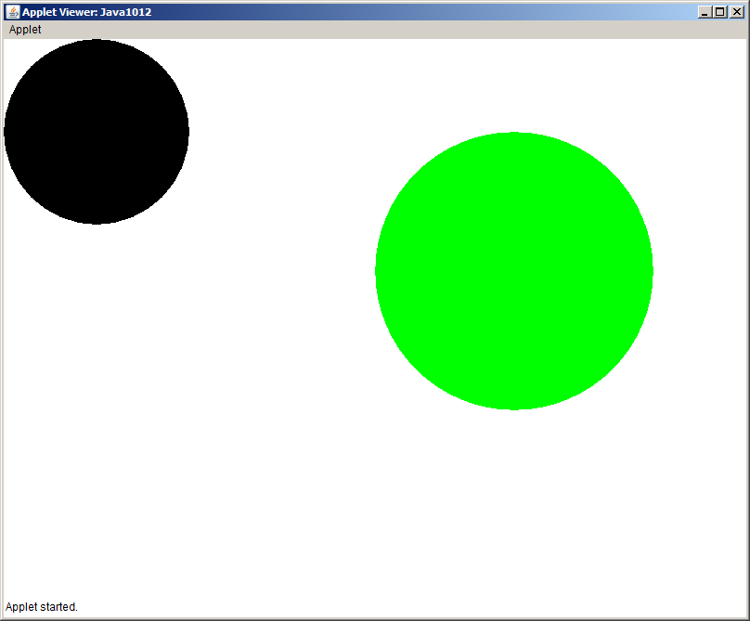

Figure 10.13
// Java1013.java
// The <Leaves> class joins the <Point> class and <Trunk> class
// as a stand-alone class ready to be used by other classes.
import java.awt.*;
import java.applet.*;
public class Java1013 extends Applet
{
public void paint(Graphics g)
{
Leaves leaves1 = new Leaves();
leaves1.drawLeaves(g);
Point start = new Point(400,100);
Leaves leaves2 = new Leaves(start,300,300,Color.blue);
leaves2.drawLeaves(g);
}
}

10.5 Class Interaction with Composition

Now that we can store coordinates, draw a tree trunk and draw leaves on a tree. The next natural step is to create a Tree class. A tree has-a trunk and a tree has leaves. This has composition written all over it. Program Java1014.java, in figure 10.14 shows a Tree class that takes advantage of the existing Point, Trunk and Leaves classes.

Figure 10.14
// Java1014.java
// The <TreeA> class uses the three stand-alone classes:
// <Point>, <Trunk> and <Leaves> to draw a tree.
// This <TreeA> class "has" three attributes that are objects
// using a composition class-interaction.
import java.awt.*;
import java.applet.*;
public class Java1014 extends Applet
{
public void paint(Graphics g)
{
Point treeStart = new Point(500,200);
int treeHeight = 500;
int treeWidth = 300;
Color trunkColor = new Color(150,100,15); // brown
Color leavesColor = Color.green;
TreeA tree = new TreeA(treeStart,treeHeight,treeWidth, trunkColor, leavesColor);
tree.drawTree(g);
}
}
class TreeA
{
private Point treeStart; // Top-mid (X,Y) coordinates of the tree
private Point leavesStart; // Top-left (X,Y) coordinates of the leaves
private Point trunkStart; // Top-left (X,Y) coordinates of the trunk
private int treeHeight;
private int treeWidth;
private Color trunkColor;
private Color leavesColor;
private int leavesHeight;
private int leavesWidth;
private int trunkHeight;
private int trunkWidth;
private Trunk trunk; // A tree "has-a" trunk
private Leaves leaves; // A tree "has-a" leaves
public Tree(Point tS, int tH, int tW, Color tC, Color lC)
{
treeStart = tS;
treeHeight = tH;
treeWidth = tW;
trunkColor = tC;
leavesColor = lC;
leavesHeight = treeWidth;
leavesWidth = treeWidth;
trunkHeight = treeHeight - leavesHeight;
trunkWidth = trunkHeight/4;
trunkStart = new Point(treeStart.getX()-(trunkWidth/2),treeStart.getY()+leavesHeight-3);
leavesStart = new Point(treeStart.getX()-(leavesWidth/2),treeStart.getY());
trunk = new Trunk(trunkStart,trunkWidth,trunkHeight,trunkColor);
leaves = new Leaves(leavesStart,leavesWidth,leavesHeight,leavesColor);
}

public void drawTree(Graphics g)
{
trunk.drawTrunk(g);
leaves.drawLeaves(g);
}
}

Figure 10.15
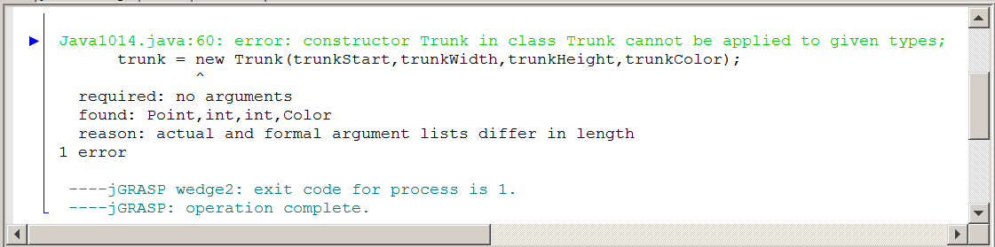

You may be surprised to get the compile error message in figure 10.15, rather than some graphics display. If you have compiled the programs in sequence an earlier, - and simpler version - of the Trunk class was compiled. The Java compiler is fundamentally lazy and when you get to program Java1014.java, Java may be quite pleased to realize that the Trunk class used in this program has already compiled.

Now that earlier Trunk class has a different set of parameters and Java gets very confused. You get rewarded with a compile error message. It is not a problem, but you need to be aware of this issue.

Load the Trunk.java file and compile this file separately. This forces Java to re-compile the Trunk class and create the proper byte code file that is needed. Now return to Java1014.java and you will see a lovely tree displayed in figure 10.16.

This problem occurs occasionally as a consequence of teaching with a sequence of similar programs that change in small steps. Anytime you encounter problems with a program that uses multiple classes, you may try compiling the classes independently. It will not happen frequently, but in a teaching environment it is more likely to cause a problem.

Figure 10.16
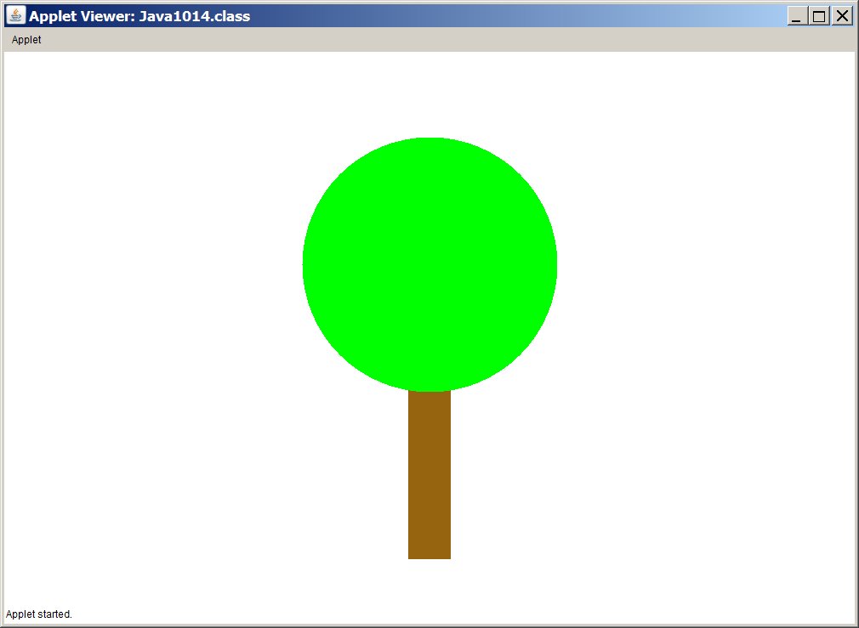

Many students will not be impressed by the humble tree that is now displayed. It seems like a lot of program statements were used to achieve this simple, little tree and most students could create this display with far less complexity. You are totally correct, but the mission is not to draw a tree. Our mission is to help you understand class interaction with composition.

The next program, Java1015.java in figure 10.17, may surprise you. After all that effort first creating the Point class, creating the Trunk class and then the Leaves class, you now see a Tree class that does use the Point class for drawing the tree, but ignores the existence of the Trunk and Leaves classes. The changes are intentional and will help to explain class interaction with inheritance in the next chapter section.

An important point needs to be made here. The aim of this book to to teach computer science to introductory students. This is not a guide in proper programming. Yes you will learn program design and learn many correct techniques, but license is sometimes taken for teaching expediency that may well be frowned upon in the programming world. One such example is the fact that you will frequently see multiple classes in one file. It helps efficient teaching, but it is not good program design.

Figure 10.17
// Java1015.java
// This version of the <Tree> class does not use
// attributes that are <Trunk> and <Leaves> objects.
// The <Tree> class also adds a default constructor.
import java.awt.*;
import java.applet.*;
public class Java1015 extends Applet
{
public void paint(Graphics g)
{
Tree tree1 = new Tree();
tree1.drawTree(g);
Point treeStart = new Point(700,50);
Tree tree2 = new Tree(treeStart,400,200,Color.blue,Color.red);
tree2.drawTree(g);
}
}
class Tree
{
private Point treeStart; // Top-mid (X,Y) coordinates of the tree
private Point leavesStart; // Top-left (X,Y) coordinates of the leaves
private Point trunkStart; // Top-left (X,Y) coordinates of the trunk
private int treeHeight;
private int treeWidth;
private Color trunkColor;
private Color leavesColor;
private int leavesHeight;
private int leavesWidth;
private int trunkHeight;
private int trunkWidth;
public Tree()
{
treeStart = new Point(400,100);
treeHeight = 500;
treeWidth = 300;
trunkColor = Color.black;
leavesColor = Color.black;
leavesHeight = treeWidth;
leavesWidth = treeWidth;;
trunkHeight = treeHeight - leavesHeight;
trunkWidth = trunkHeight/4;
leavesStart = new Point(treeStart.getX()-(leavesWidth/2),treeStart.getY());
trunkStart = new Point(treeStart.getX()-(trunkWidth/2),treeStart.getY()+leavesHeight-3);
}
public Tree(Point tS, int tH, int tW, Color tC, Color lC)
{
treeStart = tS;
treeHeight = tH;
treeWidth = tW;
trunkColor = tC;
leavesColor = lC;
leavesHeight = treeWidth;
leavesWidth = treeWidth;;
trunkHeight = treeHeight - leavesHeight;
trunkWidth = trunkHeight/4;
leavesStart = new Point(treeStart.getX()-(leavesWidth/2),treeStart.getY());
trunkStart = new Point(treeStart.getX()-(trunkWidth/2),treeStart.getY()+leavesHeight-3);
}
public void drawLeaves(Graphics g)
{
g.setColor(leavesColor);
g.fillOval(leavesStart.getX(),leavesStart.getY(),leavesWidth,leavesHeight);
}
public void drawTrunk(Graphics g)
{
g.setColor(trunkColor);
g.fillRect(trunkStart.getX(),trunkStart.getY(),trunkWidth,trunkHeight);
}
public void drawTree(Graphics g)
{
drawTrunk(g);
drawLeaves(g);
}
}

Figure 10.17 Continued
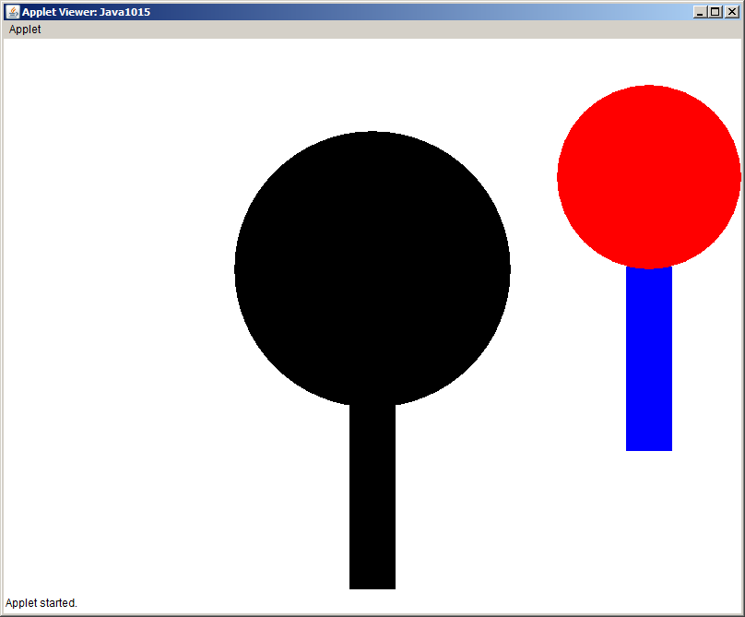
10.6 Class Interaction with Inheritance

Class interaction with inheritance involves an is-a relationship between classes. Let us consider inheritance, which is the type of inheritance where a child inherits from a parent, like Henry Ford's son. Henry Ford did more than build automobiles. He created the assembly line to makes cars very affordable.

After Henry Ford started the Ford Mootor Company, his son, Edsel Ford, took charge of his father’s company. As the new owner what can Edsel Ford do? There are three fundamental possibilities that happens in this situation: Do nothing; change something that already exists; create something new.

This means that Edsel Ford can do absolutely nothing to the car assembly plant his father created. He changes the name of the owner and the cars that drive off the assembly line will look exactly like the cars his dad created.

Well Edsel might decide that his father’s cars are rather dull. Every car is black. No car salesman asks what color you want. Are you buying a Ford? Great, the color is not an issue. Your car will be black. Edsel decides he wants to change the paint department of his factory. Cars can now be painted in five colors. In computer science this is called that you re-define or over-ride a method.

He can also create something absolutely new that did not exist previously. Edsel decides to create cars with convertible tops that change the car from enclosed to open. In computer science this is called that you newly-defined a method.

Inheritance Fundamentals
A subclass can re-define one or more methods of the superclass. This is also called over-riding a method.

A subclass can newly-define one or more methods.

A subclass can be completely empty. Nothing is re-defined or newly-defined. In such a case there is no apparent difference between the super class behavior and the subclass behavior.

When a subclass re-defines one or more methods or newly-defines one or more method, it still has access to all of the superclass methods that were not re-defined.

The Tree class is finished, placed in its own separate file, and can now be tested with some external class like Java1016.java, in figure 10.18. This Tree class will be used as the superclass of a variety of classes to explain inheritance.

Figure 10.18
// Java1016.java
// The programs will now investigate inheritance class-interaction.
// The <Tree> class is placed in an external file
// with a group of "get" and "set" methods and will
// be the superclass for various new subclasses.
import java.awt.*;
import java.applet.*;
public class Java1016 extends Applet
{
public void paint(Graphics g)
{
Tree tree = new Tree();
tree.drawTree(g);
}
}

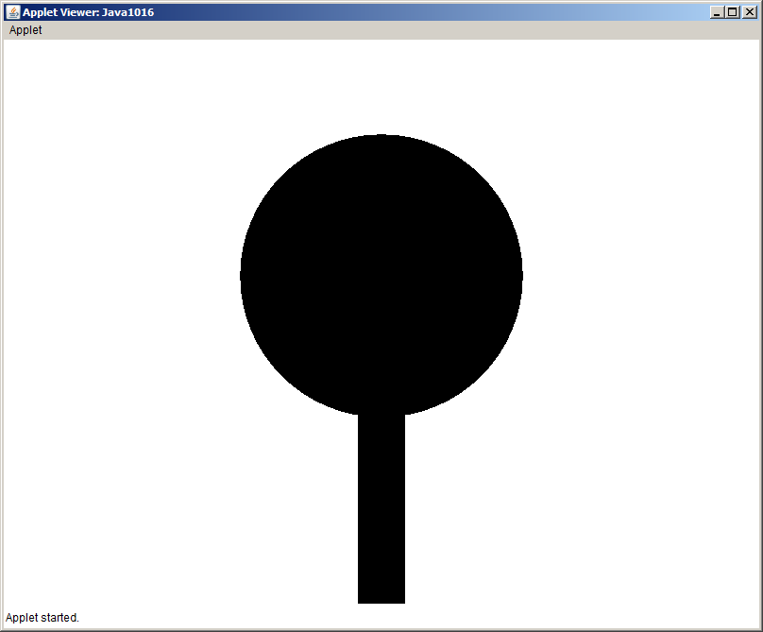
Investigating inheritance starts with a very simple, very empty subclass, called Subtree1. It is not necessary to include the Tree class in the same file. The explaining pattern is to show the current demonstration class (Subtree1) along with its testing class (Java1017.java, in figure 10.19) in the same file. You will note that drawing the Subtree1 object looks exactly like a Tree object.

Figure 10.19
// Java1017.java
// The <SubTree1> class extends the <Tree> class
// without re-defining or newly-defining any methods.
// The resulting tree display is identical to its superclass version.
import java.awt.*;
import java.applet.*;
public class Java1017 extends Applet
{
public void paint(Graphics g)
{
SubTree1 tree1 = new SubTree1();
tree1.drawTree(g);
}
}
class SubTree1 extends Tree { }

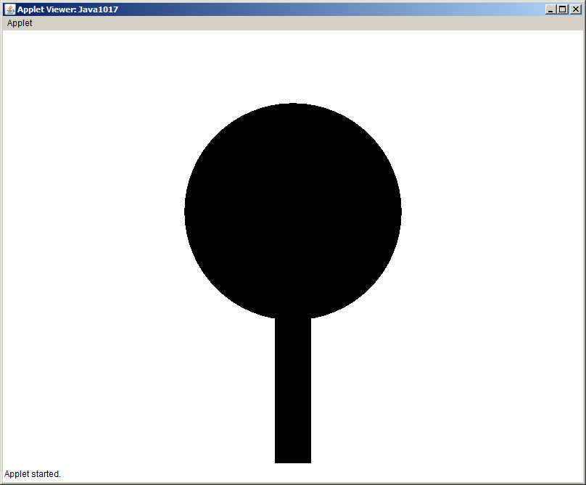
Program Java1018.java, in figure 10.20, shows that Subtree2 re-defines the constructor. You now see a different tree with green leaves. It is also important that you observe the use of the drawTree method. This method is called with subTree2 object. Method drawTree is not defined in Subtree2, but it can be used, because of inheritance.

Figure 10.20
// Java1018.java
// The <SubTree2> class extends the <Tree> class
// and defines a <SubTree2> constructor to change the <leavesColor>.
import java.awt.*;
import java.applet.*;
public class Java1018 extends Applet
{
public void paint(Graphics g)
{
SubTree2 tree2 = new SubTree2();
tree2.drawTree(g);
}
}
class SubTree2 extends Tree
{
public SubTree2()
{
setLeavesColor(Color.green);
}
}

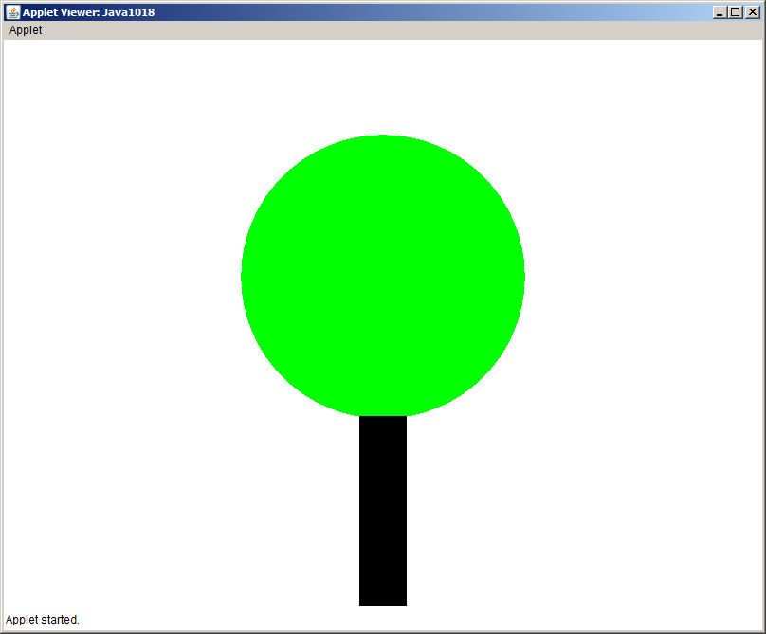
Program Java1019.java, in figure 10.21, creates a PineTree subclass. The PineTree subclass re-defines the constructor and also re-defines the drawLeaves method of the Tree class. Our new PineTree class has a new appearance.

Figure 10.21
// Java1019.java
// The <PineTree> class extends the <Tree> class
// and re-defines the <drawLeaves> method.
import java.awt.*;
import java.applet.*;
public class Java1019 extends Applet
{
public void paint(Graphics g)
{
PineTree tree3 = new PineTree();
tree3.drawTree(g);
}
}
class PineTree extends Tree
{
public PineTree()
{
setLeavesColor(Color.green);
}
public void drawLeaves(Graphics g)
{
g.setColor(getLeavesColor());
int tempX = getLeavesStart().getX();
int tempY = getLeavesStart().getY();
int topX = tempX + getLeavesWidth()/2;
int topY = tempY;
int blX = tempX;
int blY = tempY + getLeavesHeight();
int brX = tempX + getLeavesWidth();
int brY = tempY + getLeavesHeight();
Polygon triangle = new Polygon();
triangle.addPoint(topX,topY);
triangle.addPoint(blX,blY);
triangle.addPoint(brX,brY);
g.fillPolygon(triangle);
}
}

Figure 10.21 Continued
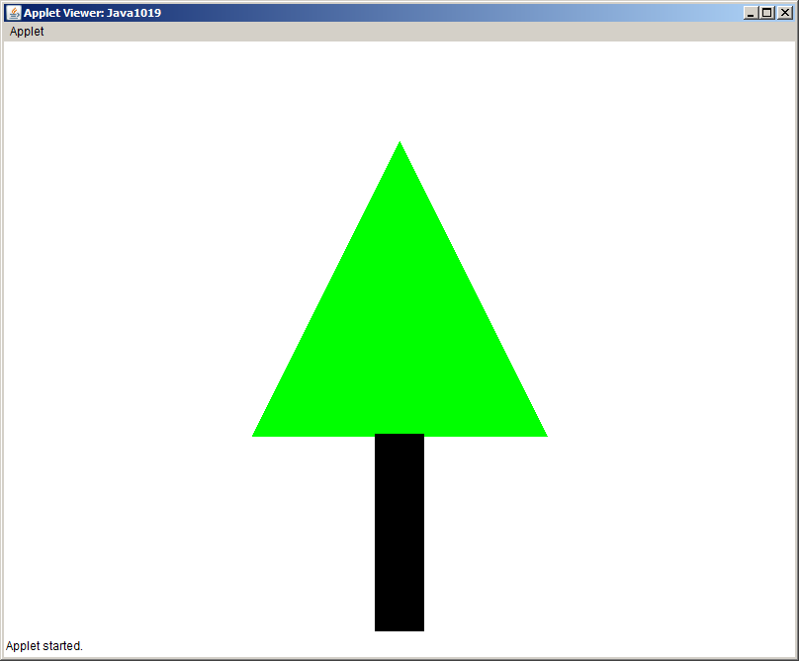

It was stated earlier that inheritance involves a subclass, which can be created with three possibilities: Do nothing; Re-define one or more methods; Newly-define one or more methods. You have done a totally empty subclass, which created an object that was 100% the same as its superclass. You have also seen various examples of re-defining the constructor and the drawLeaves methods. This certainly changed the behavior of the subclass.

Creating some brand-new methods, newly-defined methods, will be shown in the next program. The mission is to create a Christmas Tree with ornaments. It is possible to start with the Tree class, but that is not very efficient. The whole point of class interaction is to use existing classes. We have already created a PineTree class and now that subclass will take the role of a superclass.

Program Java1020.java, in figure 10.22, shows the ChristmasTree class. This subclass newly-defines the drawOrnaments method. It also re-defines the constructor to assign value to attributes topX and topY. This means that the ChristmasTree class both re-defines and newly-defines methods. At all times remember with inheritance that the new subclass has access to all public methods of the superclass, and they will behave exactly like they do for the superclass.
Figure 10.22
// Java1020.java
// The <XmasTree> class extends the <PineTree> class
// and newly-defines the <drawOrnaments> method.
import java.awt.*;
import java.applet.*;
‘
public class Java1020 extends Applet
{
public void paint(Graphics g)
{
XmasTree tree4 = new XmasTree();
tree4.drawTree(g);
tree4.drawOrnaments(g);
}
}
class XmasTree extends PineTree
{
private int topX;
private int topY;
public XmasTree()
{
topX = getLeavesStart().getX() + getLeavesWidth()/2;
topY = getLeavesStart().getY();
}
public void drawOrnaments(Graphics g)
{
g.setColor(Color.red);
g.fillOval(topX,topY+75,30,30);
g.fillOval(topX-15,topY-15,30,30);
g.fillOval(topX,topY+200,30,30);
g.fillOval(topX-50,topY+150,30,30);
g.fillOval(topX+50,topY+250,30,30);
g.fillOval(topX-100,topY+250,30,30);
}
}

Figure 10.22 Continued
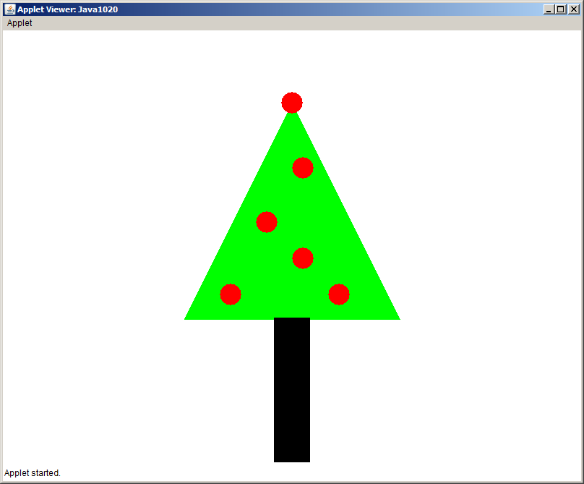

10.7 Inheritance Constructor Issues

Constructors play an important role in any class and you have learned that it is common that a class has multiple constructors. When classes interact you will find that the constructors also interact. Understanding the special requirements of constructors when inheritance is used insures that all classes operate as expected. Program Java1021.java, in figure 10.23, defines the Person and Student constructors with output statements.

Figure 10.23
// Java1021.java
// Note how the <Person> constructor is called, even though there does
// not appear to be a <Person> object instantiated.

public class Java1021
{
public static void main(String[ ] args)
{
Student tom = new Student();
System.out.println("tom's age is " + tom.getAge());
System.out.println("tom's grade is " + tom.getGrade());
System.out.println();
}
}

class Person
{
private int age;

public Person()
{
System.out.println("Person Constructor");
age = 17;
}

public int getAge()
{
return age;
}
}

class Student extends Person
{
private int grade;

public Student()
{
System.out.println("Student Constructor");
grade = 12;
}

public int getGrade()
{
return grade;
}
}

Figure 10.23 Continued
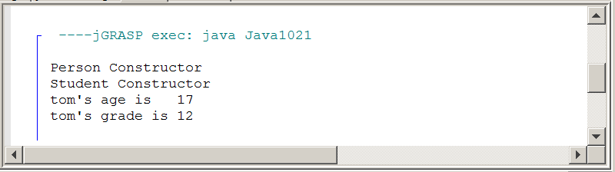

There is a Student object, called tom, constructed. The single new operator calls the Student() constructor method and it is reasonable in the output, that you see Student Constructor. What about the Person Constructor output?
There is not a new Person() statement in the program and yet the evidence displays that somehow the Person constructor is called.

If a custom van is-a van, does it not start with a van first? Is it not required first to construct a van before you can construct a custom van? This is precisely what happened in program Java1021.java. One object is instantiated, but the tom object starts its life by first becoming a Person and then becoming a Student.

Program Java1022.java helps to explain exactly how Java uses a super class object first. The program is almost identical to the previous program output. The only difference is shown in figure 10.24 where you can compare both of the two Student constructors. The second program uses a call to a super method, which calls the superclass constructor.

Figure 10.24
Java1021 Student constructor

public Student()
{
System.out.println("Student Constructor");
grade = 12;
}

Java1022 Student constructor

public Student()
{
super(); // must be first statement in the constructor
System.out.println("Student Constructor");
grade = 12;
}

Inheritance and Constructors Calls
When an object of a subclass is instantiated, the constructor of the superclass is executed first, followed by completing the execution of the subclass constructor.

An invisible - to the programmer - call is made by Java to the super method, which generates a call to the superclass constructor. This statement can be written in the subclass constructor with the same results, but it is not required.

Passing Information to SuperClass Constructors

You have seen various program examples involving both inheritance and constructors. In each case, evidence showed that the constructor of the superclass is executed first followed by executing the constructor of the subclass. In each example, the superclass constructor used was a no-parameter, default constructor. This begs the question what might happen if parameter constructors are used, and how is information passed in such a case on to the superclass?

Program Java10.23.java, in figure 10.25, shows the data information path. The process starts by creating a new Student object tom. The Student constructor is called first with parameter information (12,17).

The 12 is meant to be the value for the grade data attribute of the Student class and the 17 is meant to be the value for the age data attribute of the Person class. The statement new Student(12,17) passes parameter values to the constructor method heading of Student. You have seen that a superclass object must be constructed first and that means that the 17 value needs to travel to the superclass constructor before anything can happen in the Student subclass constructor.

Note, that the very first statement in the subclass constructor is super(a). Variable a (for age) has received a copy of the actual parameter 17 and the superclass Person constructor is now called with the 17 value for age.

After the superclass is satisfied, the g parameter provides the 12 value to the grade attribute of the Student class. Java is happy and all the attributes have received the proper value in the proper sequence.

Figure 10.25
// Java1023.java
// This program demonstrates how a subclass constructor passes
// parameter information to a superclass constructor.

public class Java1023
{
public static void main(String[ ] args)
{
Student tom = new Student(12,17);
tom.showData();
}
}

class Person
{
protected int age;

public Person(int a)
{
System.out.println("Person Parameter Constructor");
age = a;
}

public int getAge()
{
return age;
}
}

class Student extends Person
{
protected int grade;

public Student(int g, int a)
{
super(a); // this must be the first call
grade = g;
System.out.println("Student Parameter Constructor");
}

public int getGrade()
{
return grade;
}

public void showData()
{
System.out.println("Student's Grade is " + getGrade());
System.out.println("Student's Age is " + getAge());
}
}

Figure 10.25 Continued
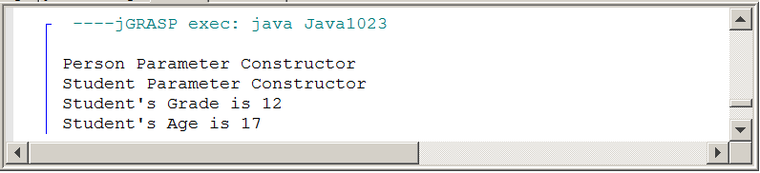

This parameter passing business to superclass constructors can happen at multiple levels. Program Java1024.java, in figure 10.26, has three classes and information needs to be provided for attributes at three different levels.

The highest superclass is Animal. This is followed by Mammal, which extends Animal. In this situation Mammal is the subclass of Animal and simultaneously takes on the role of being the superclass of the Cat class. This type of interaction is actually quite natural when you view your own world. Every person is a child and then many children become parents. For many years a person will be both a child and a parent.

Parameter passing in this three-level inheritance example starts at the bottom. The testing class creates a Cat object tiger and calls the Cat constructor with three data values.

The Cat constructor receives the three data values and first passes two values to the superclass Mammal with the statement super(w,a). At the second level another super(a) statement is used to pass age to the highest super class. This process can be used a large number of inheritance levels.

Figure 10.26
// Java1024.java
// This program demonstrates inheritance at three levels.

public class Java1024
{
public static void main(String[ ] args)
{
Cat tiger = new Cat("Tiger",500,5);
System.out.println();
System.out.println("Animal type: " + tiger.getType());
System.out.println("Animal weight: " + tiger.getWeight());
System.out.println("Animal age: " + tiger.getAge());
}
}

class Animal
{
protected int age;

public Animal(int a)
{
System.out.println("Animal Constructor Called");
age = a;
}

public int getAge()
{
return age;
}
}

class Mammal extends Animal
{
protected int weight;

public Mammal(int w, int a)
{
super(a);
weight = w;
System.out.println("Mammal Constructor Called");
}

public int getWeight()
{
return weight;
}
}

class Cat extends Mammal
{
protected String type;

public Cat(String t, int w, int a)
{
super(w,a);
type = t;
System.out.println("Cat Constructor Called");
}

public String getType()
{
return type;
}
}

Figure 10.26 Continued
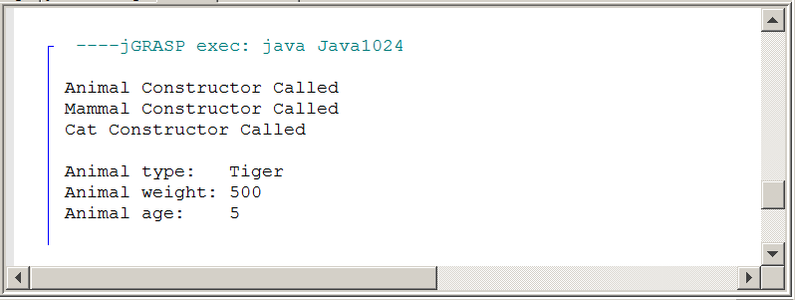

When you talk about Multi-Level Inheritance, be careful that you say it properly. There is something else called Multiple Inheritance which sounds similar, but is completely different. In Multiple Inheritance, one subclass can have multiple super classes. One way to explain the difference is to look at the Terrier and the Dinosaur, below. A dinosaur is-a reptile, and a dinosaur is also extinct. Something else to keep in mind, Java allows Multi-Level Inheritance, but it does NOT allow Multiple Inheritance. Some languages, like C++, allow multiple inheritance.

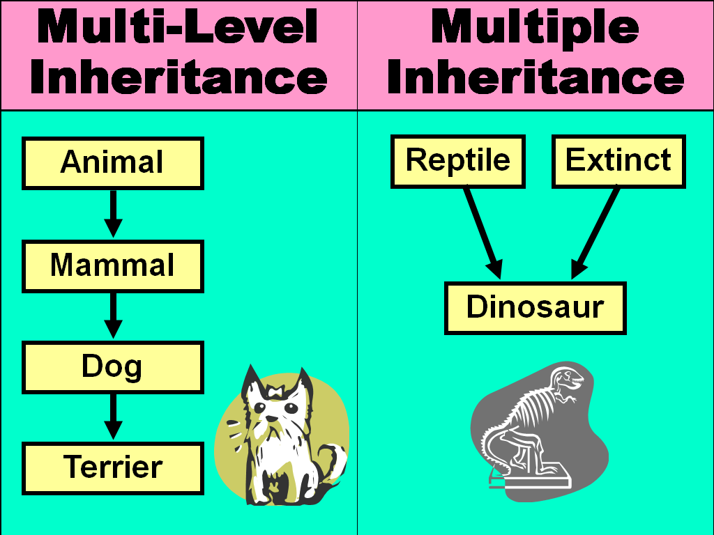

10.8 Calling a Superclass Method

All the program examples have conveniently used method identifiers in the Person and Student class that are not identical. Considering the fact that a major reason for using inheritance is the re-definition of existing method, it should be quite common to use identical identifiers in multiple classes. How does Java handle this confusion? These questions are answered by this section starting with program Java1025.java, shown in figure 10.27. In that program example both the Person class and the Student class use method getData to return the data information of the class.

Java executes the method that is defined by the object that you are using. Now what happens if you have a Student object and you do not want to call the Student getData method; you want the Person getData method. Figure 10.27 actually calls getData twice with the intention to get two different values. This requirement is handled by using super in front of getData to indicate the superclass method.

Figure 10.27
// Java1025.java
// This program demonstrates that it is possible to distinguish between
// two methods with the same identifier using <super>.

public class Java1025
{
public static void main(String[ ] args)
{
Student tom = new Student(12,17);
tom.showData();
}
}

class Person
{
private int age;

public Person(int a)
{
System.out.println("Person Parameter Constructor");
age = a;
}

public int getData()
{
return age;
}
}

class Student extends Person
{
private int grade;

public Student(int g, int a)
{
super(a);
grade = g;
System.out.println("Student Parameter Constructor");
}

public int getData()
{
return grade;
}

public void showData()
{
System.out.println("Student's Grade is " + getData());
System.out.println("Student's Age is " + super.getData());
}
}

Figure 10.27 Continued
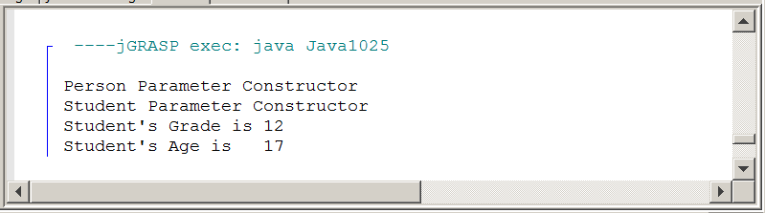

Using super
The keyword super used as the first statement in a constructor passes information to the super class constructor, like super(a);

The same keyword super used in front of a method indicates that a method of the superclass needs to be called, like super.getData();

Information can be passed up to multiple inheritance levels, but it can only be passed one level at one time.

10.9 The Object Class

There are some mysteries in the Java programming language. For example, how is it possible to use the print method with a String object and all the individual characters are printed? There is a problem when you create your own class. You cannot simply use print to display the attribute values stored in an object of your class. The mystery of output display will be explained and you will learn how to create your own class in such a manner that any desired values will be displayed using print without benefit of any special loop structure.

There seems a similar mystery in the areas of equality checking. Some variables, like simple data types can be checked for equality with the equality operator and others, like String objects, require the use of the equals method. The question once again about user-defined classes pops up. Can user-defined objects be tested for equality, and if so how is this done?

It turns out that there are two methods, toString and equals that have been defined for many Java standard classes. These methods can also be defined for any user-defined classes.

Methods toString and equals are short, humble methods, but they carry a punch. User-defined classes can be personalized with the aid of these two methods for very specific properties and convenience for the use of the new classes.

This story starts by looking at an invisible class that is present in every Java program that is written. This magical class, called Object, is the superclass of all the Java standard library classes. It is the superclass of any class that you have created and it will be the superclass for any future class that you will create. Program Java1026.java, in figure 10.28, shows a program with two classes.

Figure 10.28
// Java1026.java
// This program intentional extends the two classes with
// Object as the superclass. This is done automatically.

public class Java1026 extends Object
{
public static void main (String[ ] args)
{
Qwerty q = new Qwerty();
}
}

class Qwerty extends Object
{
public Qwerty()
{
System.out.println("Constructing Qwerty Object");
}
}

Figure 10.28 Continued
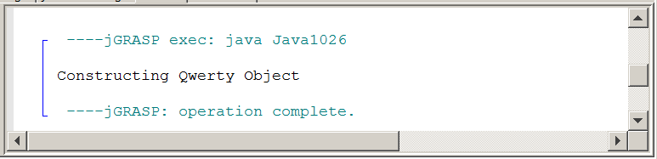

Personally, I am not real thrilled with the name Object for a class. In an earlier chapter there were many examples, using the old GridWorld Case Study, that showed the difference between a class and an object. A class is a category and an object is one instance of the category. Student is a class and tom is one instance of Student. So now we have a class, which cleverly is named Object. Please do not get confused. Also do not use the syntax shown in program Java1026.java. You do not write a program and extend the Object class. It was only shown so that you see that Java is very comfortable extending this Object class.

The impact of a single class that is the superclass to any and all classes is quite profound. This means that any class that you ever see anywhere has excess to the method definitions that exist in the Object class. Like all subclasses there is the option to re-define any superclass method. However, if a superclass method is not re-defined you will get the version that is defined in the superclass. The Object class has a fair set of methods, but we are only concerned with two specific methods, called toString and equals. We will return to these methods shortly, but first some other program examples need to be presented to help clarify this Object story better.

You have taken the humble print and println methods for granted for many months. It is such an easy set of methods to use. Everything inside the parentheses is displayed in a nice concatenated fashion. Anything placed between double quotes is displayed literally and variables are displayed according to the value they hold. At least that seems to be the case.

We will start by investigating the output of various print environments and then explain how print actually performs its job. Program Java1027.java, in figure 10.29, uses print with a String object and a literal string. The literal string is displayed precisely as it is seen between the quotes and the String variable displays the value that it stores.

Figure 10.27
// Java1027.java
// This demonstrates how <String> class objects are printed.

public class Java1027
{
public static void main (String[ ] args)
{
String stringVar = "Tango";
System.out.println(stringVar);
System.out.println();
System.out.println("Literal String");
System.out.println();
}
}

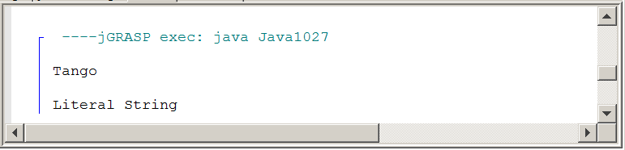

Program Java1028.java, in figure 10.30, uses println with each one of four different primitive Java data types, int, double, char and boolean. Four appropriate values are assigned to the variables and then displayed with println.

Figure 10.28
// Java1028.java
// This demonstrates how <int>, <double>, <char> and <boolean> variables are printed.

public class Java1028
{
public static void main (String[ ] args)
{
int intVar = 100;
double dblVar = 3.14159;

char chrVar = 'A';
boolean blnVar = true;
System.out.println(intVar);
System.out.println(dblVar);
System.out.println(chrVar);
System.out.println(blnVar);
}
}

Figure 10.30 Continued
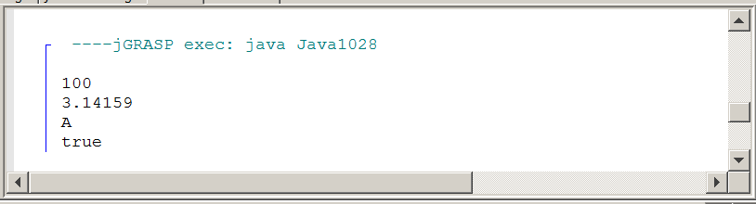

Our investigation is not finished. Program Java1029.java, in figure 10.31, takes a look at a user-defined Student class. Each Student object stores age and gpa data information. After three objects are constructed, each object is displayed using the println method. The program output shows the Student class name followed by a base-16 computer memory address.

Figure 10.31
// Java1029.java
// In this program objects of a user-defined <Student> class are
// used with <print> statement.

public class Java1029
{
public static void main (String[ ] args)
{
Student tom = new Student(21,3.85);
Student sue = new Student(17,3.65);
Student bob = new Student(18,2.85);
System.out.println("tom: " + tom);
System.out.println("sue: " + sue);
System.out.println("bob: " + bob);
}
}

class Student
{
private int age;
private double gpa;

public Student(int a, double g)
{
age = a;
gpa = g;
}
}

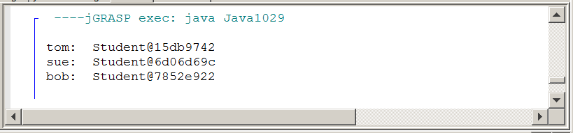

Student is a class and its objects store memory references to its data attributes. It helps to consider that objects use shallow values and deep values. This concept is shown below. The three Student objects, tom, sue and bob each start with a memory location that stores a memory reference, to another - deeper - memory location. At this deeper location we find that the actual data is stored. In this case @15db9742, @6d06d69c and @785e922 are the shallow values of tom, sue and bob. (21,3.85), (17,3.65) and (18,2.85) are the deeper values.
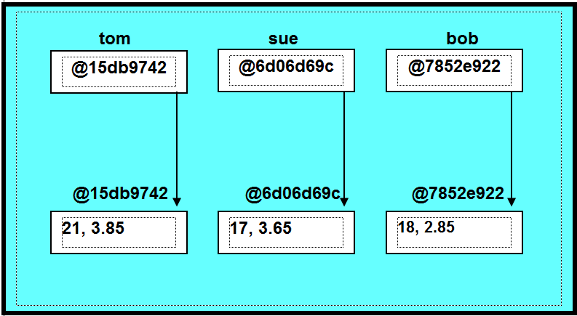

If you check the output in figure 10.31, you will see that each object displays the class name Student followed by a memory reference, which is the shallow value of the object. The deeper, certainly more practical values of the ages and GPAs, are not displayed anywhere.

The answer to this memory reference output is connected with the Object class that was mentioned earlier. In this class are various methods. Since the Object class is the superclass for every class in Java, this means that the methods in the Object class are available to every class used by Java past and present.

One of the methods in the Object class is called toString and this method returns a string of characters. This is not just any random string of characters, but the shallow value of the object that uses the toString method.

It may help to look at our program again with a slight change. This time program Java1030.java, in figure 10.32, is once again displaying three Student objects, but something is going on with the println statements.

The program output is exactly the same as the previous program. This indicates that the println method automatically calls the toString method of the object that it is supposed to display. Since the toString method is programmed to return the shallow value of its object, that is precisely what you get, a memory reference.

Figure 10.32
// Java1030.java
// Each println statement includes a call to the <toString>
// method, which is defined to return the shallow value of
// the object.
public class Java1030
{
public static void main (String[ ] args)
{
Student tom = new Student(21,3.85);
Student sue = new Student(17,3.65);
Student bob = new Student(18,2.85);
System.out.println("tom: " + tom.toString());
System.out.println("sue: " + sue.toString());
System.out.println("bob: " + bob.toString());
}
}

class Student
{
private int age;
private double gpa;

public Student(int a, double g)
{
age = a;
gpa = g;
}
}

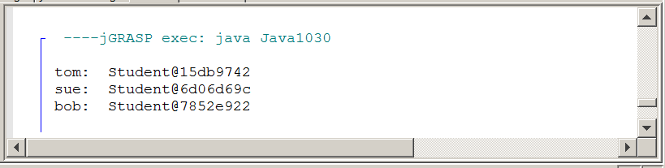

The Original toString Method of the Object Class
print and println request display instructions from the toString method. Method toString is defined by the Object class. The Object class is the superclass for all Java classes. This means that every class has access to the toString method.

The toString method, as defined by the Object class, returns the actual string representation values of all the primitive types like int, double, char and boolean.

toString returns the class name followed by the memory reference of any variable object.

10.10 Re-defining the toString Method

Displaying memory references is not very exciting. In program Java1031, shown in figure 10.33, method toString is re-defined in the Student class. This will override the original toString method of the Object class and in this case the age value of the student is returned.

Figure 10.31
// Java1031.java
// Each println statement includes a call to the <toString>
// method, which is defined to return the shallow value of the object.
public class Java1031
{
public static void main (String[ ] args)
{
Student tom = new Student(21,3.85);
Student sue = new Student(17,3.65);
Student bob = new Student(18,2.85);
System.out.println("tom: " + tom);
System.out.println("sue: " + sue);
System.out.println("bob: " + bob);
}
}
class Student
{
private int age;
private double gpa;
public Student(int a, double g)
{
age = a;
gpa = g;
}
public String toString()
{
return "" + age;
}
}

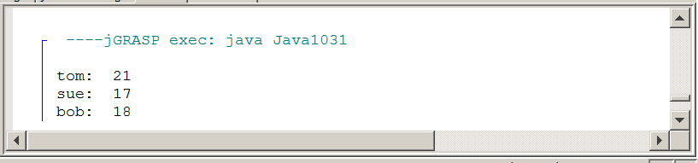

You may wonder about the return "" + age; return statement of method toString. Method toString is a return method and requires that the data type returned is a String. The statement return age; will not compile. Using a set of double quotes adds an empty string to the return value and also creates a concatenation statement that returns a string with the value of age.

Re-definition of the toString method is not limited to a single attribute value. Program Java1032.java, in figure 10.34. Adds name as a Student attribute and displays all the attributes with a different toString method. The output is also placed between square brackets and separated by commas.

In the println statement everything is removed, except for the object name. The output that is seen by figure 10.34 is the result of displaying what is returned by the toString method of the Student class.

Figure 10.34
// Java1032.java
// The <toString> method is re-defined to return all the
// attribute values in the [Tom, 21, 3.85] format.
public class Java1032
{
public static void main (String[ ] args)
{
Student student1 = new Student("Tom",21,3.85);
Student student2 = new Student("Sue",17,3.65);
Student student3 = new Student("Bob",18,2.85);
System.out.println(student1);
System.out.println(student2);
System.out.println(student3);
}
}
class Student
{
private String name;
private int age;
private double gpa;
public Student(String n, int a, double g)
{
name = n;
age = a;
gpa = g;
}
public String toString()
{
return "[" + name + ", " + age + ", " + gpa + "]";
}
}

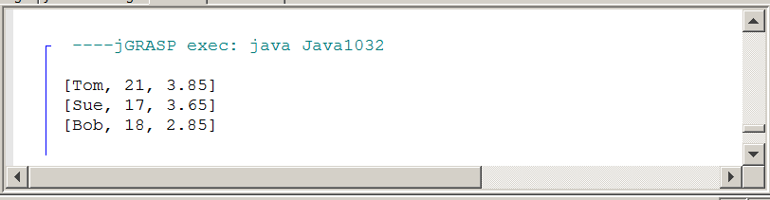
There will be one more example of re-defining the toString method. You need to realize that Java cares nothing about making sense. Java follows instructions. In figure 10.35 you see the Student class with an odd toString method. This method returns Aardvark regardless of the attribute values.

Figure 10.35
class Student
{
private String name;
private int age;
private double gpa;
public Student(String n, int a, double g)
{
name = n;
age = a;
gpa = g;
}
public String toString()
{
return "Aardvark";
}
}

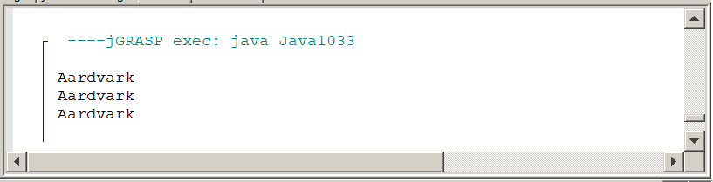

10.11 Re-defining the equals Method

In the same way that the toString method can be re-defined, we can also re-define the equals method. You have already seen this method in use when we were comparing strings in an earlier chapter. You may remember that the equality operator == does not work for strings because it merely checks to see if the shallow memory addresses are equal, not the contents in the deeper memories. What we can now say is that the == operator merely checks to see if the shallow values are equal, but does not compare the deep values. This issue is not exclusive to String objects. It actually applies to all objects. When comparing objects how do you determine if they are equal? Program Java1034.java, in figure 10.36, tries to compare two Person objects with the == operator.

Figure 10.36
// Java1034.java
// This program tries to compare 2 person objects with the == operator.
// This does not work because the == operator only checks the shallow value.
// It also does not give us a way to determine how we will check for equality.

public class Java1034
{
public static void main (String[ ] args)
{
Person tom = new Person("Tom Jones",36,'M',40000);
Person sue = new Person("Sue Smith",29,'F',50000);
Person bob = new Person("Bob Brown",40,'M',50000);

System.out.println(tom);
System.out.println(sue);
System.out.println(bob);
System.out.println();

if (tom == sue)
System.out.println("Tom and Sue are equal.");
else
System.out.println("Tom and Sue are not equal.");

if (tom == bob)
System.out.println("Tom and Bob are equal.");
else
System.out.println("Tom and Bob are not equal.");

if (sue == bob)
System.out.println("Sue and Bob are equal.");
else
System.out.println("Sue and Bob are not equal.");
System.out.println();
}
}
class Person
{
private String name;
private int age;
private char gender;
private double salary;

public Person(String n, int a, char g, double s)
{
name = n;
age = a;
gender = g;
salary = s;
}

public String toString()
{
return "[" + name + ", " + age + ", " + gender + ", " + salary + "]";
}
}

Figure 10.36 Continued
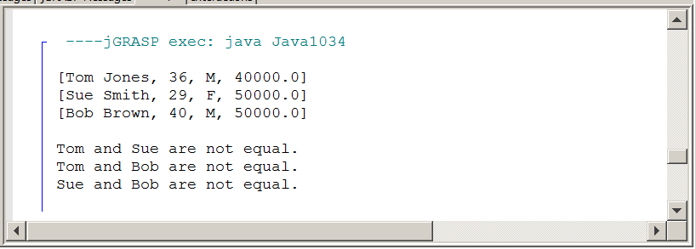

The program output indicates that none of the Person objects are equal to each other. There is a double issue with this program.

Number one: there is no sense of what is meant by equality. Does it mean that the incomes are equal? Can it be that ages are compared or perhaps the names of the people? Nothing is established to address this concern.

Number two: use of the == operator is meant for simple or primitive data types. This means that equality is tested at the shallow address location. Objects are memory references and will not be equal.

Program Java1035.java, in figure 10.37, attempts to solve the problem of the previous program. This time the == is not used and replaced with the equals method. It makes sense to use the equals method. You saw that this approach worked correctly when String objects are compared for equality.

You should realize that there will still be issues. Perhaps the equals method does a better job comparing objects, but it is different than strings. If there are two names, which are strings then the names are compared for equality. Now you have objects with multiple attribute values. What is the criteria for equality? Unless this is decided and then used in some type of comparison, Java will remain pretty confused. The output will probably not be very satisfactory.

Figure 10.37
// Java1035.java
// This program tries to compare two <Person> objects with the <equals< method.
// This also does not work because we have not "re-defined" the <equals> method
// for the <Person> class, and we are simply inheriting the <equals> method from
// the <Object> class, which only checks the shallow value.

public class Java1035
{
public static void main (String[ ] args)
{
Person tom = new Person("Tom Jones",36,'M',40000);
Person sue = new Person("Sue Smith",29,'F',50000);
Person bob = new Person("Bob Brown",40,'M',50000);
System.out.println(tom);
System.out.println(sue);
System.out.println(bob);
System.out.println();
if (tom.equals(sue))
System.out.println("Tom and Sue are equal.");
else
System.out.println("Tom and Sue are not equal.");
if (tom.equals(bob))
System.out.println("Tom and Bob are equal.");
else
System.out.println("Tom and Bob are not equal.");
if (sue.equals(bob))
System.out.println("Sue and Bob are equal.");
else
System.out.println("Sue and Bob are not equal.");
System.out.println();
}
}

class Person
{
private String name;
private int age;
private char gender;
private double salary;

public Person(String n, int a, char g, double s)
{
name = n;
age = a;
gender = g;
salary = s;
}

public String toString()
{
return "[" + name + ", " + age + ", " + gender + ", " + salary + "]";
}
}

Figure 10.37 continued
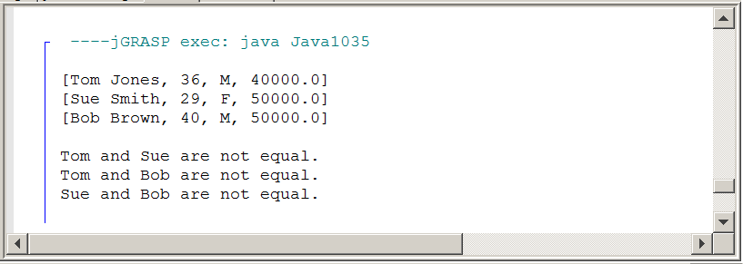

The equals method, like its toString cousin, is first defined in the Object class. At the original definition in the Object class, equality is based on shallow values. Pretty much the same issue as the == operator.

So how does the String class solve its equality problem? Just like the toString method. The equals method needs to be re-defined, just like it was done with the toString method. Program Java1035.java does what it is told to do and not what it is meant to do.

Program Java1036.java, in figure 10.38, works correctly, provided the mission is to compare equality based on salary. The equals method is re-defined for the Person class to create the desired result. Now Sue and Bob are considered equal based on their annual salary.

Figure 10.38
// Java1036.java
// This program properly compares two person objects with the redefined equals method.
// It chooses to define "equality" solely based on a Person's salary, which may be
// overly capitalistic, but still makes a point.

public class Java1036
{

public static void main (String[ ] args)
{
Person tom = new Person("Tom Jones",36,'M',40000);
Person sue = new Person("Sue Smith",29,'F',50000);
Person bob = new Person("Bob Brown",40,'M',50000);
System.out.println(tom);
System.out.println(sue);
System.out.println(bob);
System.out.println();

if (tom.equals(sue))
System.out.println("Tom and Sue are equal.");
else
System.out.println("Tom and Sue are not equal.");

if (tom.equals(bob))
System.out.println("Tom and Bob are equal.");
else
System.out.println("Tom and Bob are not equal.");

if (sue.equals(bob))
System.out.println("Sue and Bob are equal.");
else
System.out.println("Sue and Bob are not equal.");
System.out.println();
}
}

class Person
{
private String name;
private int age;
private char gender;
private double salary;

public Person(String n, int a, char g, double s)
{
name = n;
age = a;
gender = g;
salary = s;
}

public String toString()
{
return "[" + name + ", " + age + ", " + gender + ", " + salary + "]";
}

public boolean equals(Person temp)
{
return salary == temp.salary;
}

}

Figure 10.38 continued
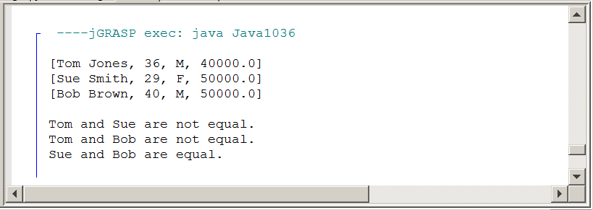

Program Java1037, in figure 10.39, shows that the equals method can be easily altered for a different comparison. This equality is based on total equality in each of the Person's object fields. You will notice a special keyword, this, is included. This keyword (pun intended) is optional. It exists to help distinguish between different objects.

Figure 10.39
// Java1037.java
// This program defines equality differently from the previous programs.
// Now all data fields must match for two Person objects to be considered equal.
// A special <this> reference in the equals method helps to distinguish the two objects.
// NOTE: It is not uncommon for the equals method from one class to call the
// equals method from another class.

public class Java1037
{
public static void main (String[ ] args)
{
Person tom = new Person("Tom Jones",36,'M',40000);
Person sue = new Person("Sue Smith",29,'F',50000);
Person bob = new Person("Bob Brown",40,'M',50000);
System.out.println(tom);
System.out.println(sue);
System.out.println(bob);
System.out.println();

if (tom.equals(sue))
System.out.println("Tom and Sue are equal.");
else
System.out.println("Tom and Sue are not equal.");
if (tom.equals(bob))
System.out.println("Tom and Bob are equal.");
else
System.out.println("Tom and Bob are not equal.");

if (sue.equals(bob))
System.out.println("Sue and Bob are equal.");
else
System.out.println("Sue and Bob are not equal.");
}
}

class Person
{
private String name;
private int age;
private char gender;
private double salary;

public Person(String n, int a, char g, double s)
{
name = n; age = a; gender = g; salary = s;
}

public String toString()
{
return "[" + name + ", " + age + ", " + gender + ", " + salary + "]";
}

public boolean equals(Person that)
{
return this.name.equals(that.name) &&
this.age == that.age &&
this.gender == that.gender &&
this.salary == that.salary;
}

}

Figure 10.39 continued
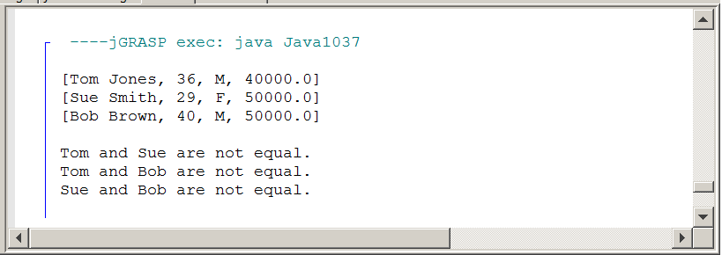

Technically, the equals methods of the last two programs were not correct. When a subclass re-defines a method of a superclass, the heading of the superclass method must be identical. If the heading is not identical, it is not overriding the definition of the superclass method.
The heading of the equals method in superclass Object is as follows:

public boolean equals(Object other)

The headings of the last two programs are similar, but not exactly the same. The headings were as follows:

public boolean equals(Person temp)
public boolean equals(Person that)

Using parameters temp and that worked fine and any identifier may be used in its place. The problem is with the class identifier Person. In the Object superclass any class can be compared and the only class that can be an umbrella for all classes is the Object class.

This does present a problem, because Java will not realize what class is used for comparisons. Program Java1038.java, in figure 10.40, shows the solution is to use a class cast with the Person class. Only the altered equals method is shown.

Figure 10.40
public boolean equals(Object that)
{
return this.salary == ( (Person) that).salary;
}

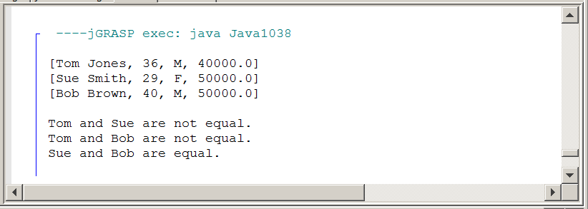
10.12 Summary

This chapter provided a little information into a variety of topics that are all closely related. Java is an object oriented programming language, and the three corner stones of OOP are encapsulation, class interaction and polymorphism. In this chapter the OOP focus is on class interaction. Class Interaction itself is divided into Composition and Inheritance.

With inheritance it is possible to use existing classes with all their available features, both methods and attributes. The existing class is called the superclass and the new class derived from the superclass is called the subclass. Inheritance involves an "is-a" relationship. This means that first and foremost every subclass "is-a" superclass.

Geometry provides good examples, such as a square is-a rectangle. In Java the reserved word extends is used to indicate that a class declaration is a subclass of an existing superclass.

It is very important not to confuse inheritance with composition. A new class can be declared that includes existing components. A new class may have multiple members, which are objects of existing classes. In such a case the new class demonstrates a "has-a" relationship, because it has certain other members.

We can also say that the new class is composed of other components and hence the term composition. In Geometry we do not say a rectangle is-a lines, but we certainly can say a rectangle has lines.

The biggest benefit of composition and inheritance is the ability to use finished program components, called classes, that have already been created and tested.

New and improved versions of existing components can be designed without starting from scratch. This improves program design efficiency as well as increase program reliability.

With composition the new class has one or more attributes that use objects of existing classes. No attempt is made to alter any methods of the included class. With inheritance the subclass creates a new class with new methods. Some methods have the same identifier as the superclass methods. In such a case you are re-defining existing methods.

In some other cases there are completely new methods with new identifiers. In the second case you are newly-defining methods. Whether it is composition or inheritance, the point is not to reinvent the wheel and take advantage of existing classes.

The creation of a subclass involves three possibilities:

1: Nothing is changed, which means all inherited methods have the features of the superclass.

2: One or more methods can be redefined.

3: Finally, methods can be newly defined that never existed.

Special concern needs to be given to properly passing information to the constructor of a superclass. Use of the super method as a first call in a subclass constructor can pass information to the superclass constructor. super can also be used with a method to indicate that the method of a superclass needs to be called rather than the redefined subclass method.

Java has a special superclass that is the superclass to all Java library classes and and any user-defined class. The class is called Object. Any method in this class can be used by any Java class. Two methods defined in the Object class are toString and equals.

The toString method returns a string value and seems rather innocent. The real significance is that the print and println methods automatically call method toString and display what is returned. In the Object class method toString is defined to return the shallow value of an object. Any attempt to display the value of an object, like System.out.println(tom); where tom is an object of the Person class will result in the word Person followed by a memory reference.

However, if method toString is redefined in the Person class to return the values of the name and age attributes, then these two values will be displayed. One example of such a redefined toString method is shown below.

public String toString()
{
return name + age;
}

The equals method is also defined in the Object class to consider shallow values only. All objects store memory references for shallow values. Comparisons made at this level will not be accurate.

Once again it is possible to redefine the equals method in a manner that is desired. In the case of the Person class, equality can be based on the age attribute. The number of attributes is not an issue. The equals method compares its calling object (this) with its parameter object. A boolean value is returned based on the selected comparison.

